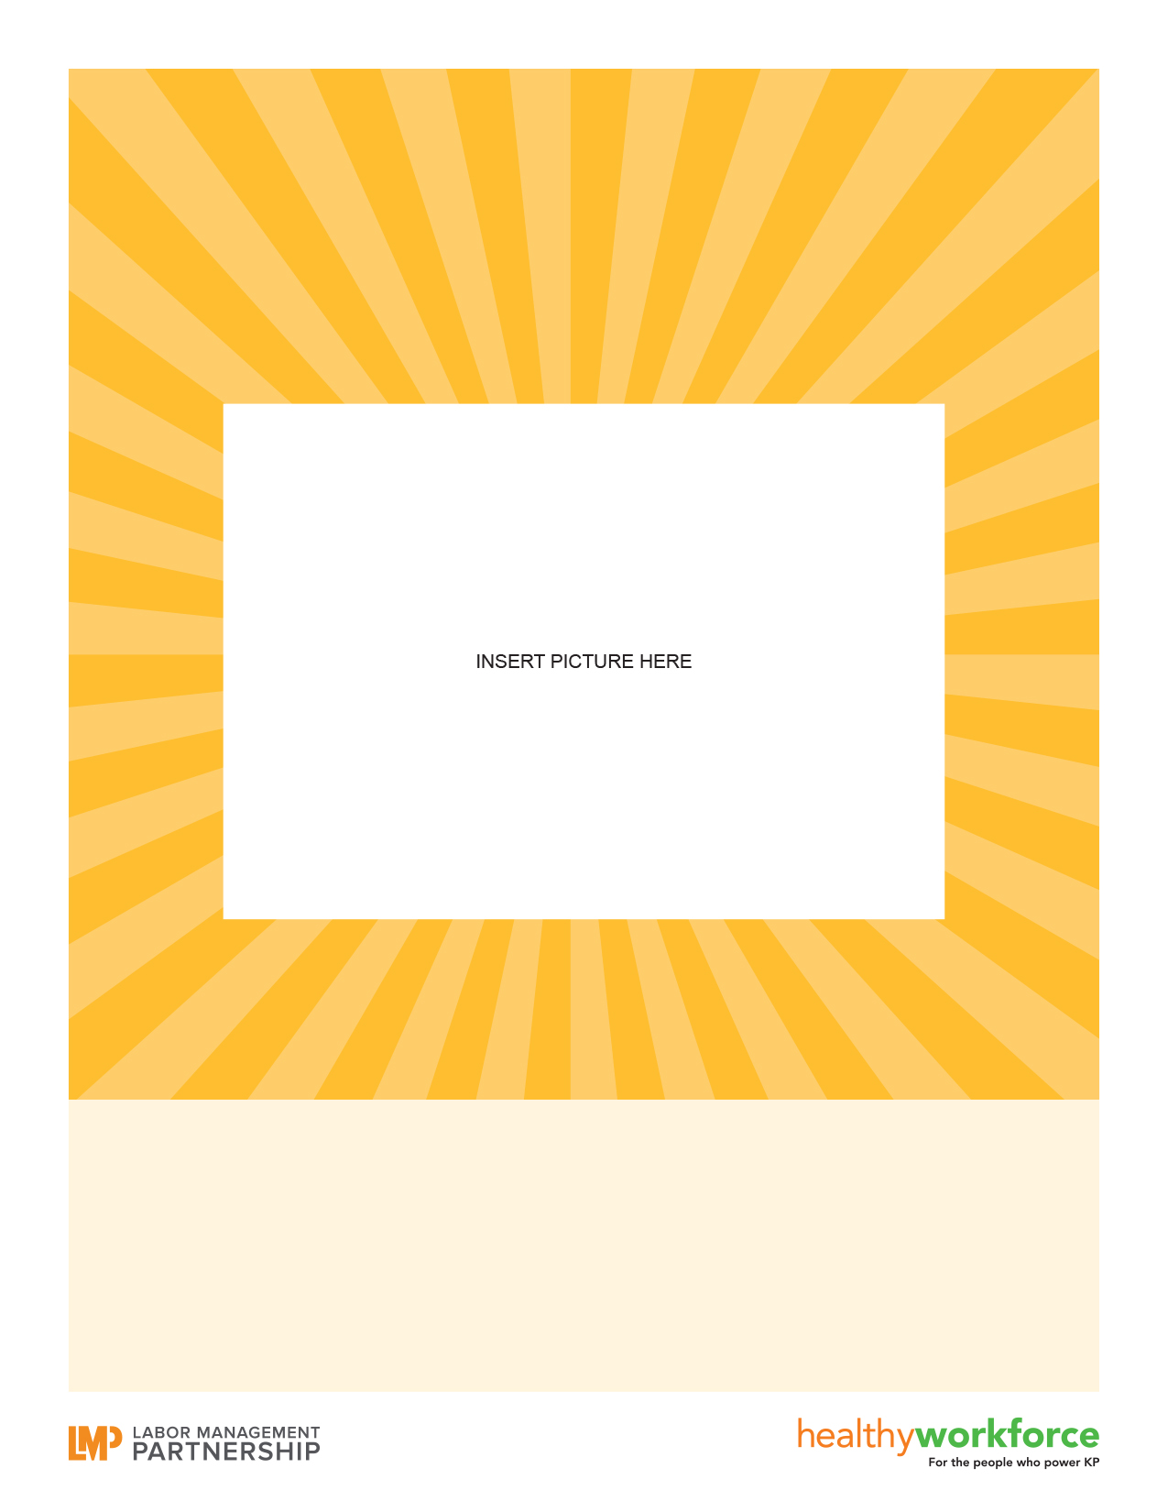

Caption goes here

**HEADLINE GOES HERE**