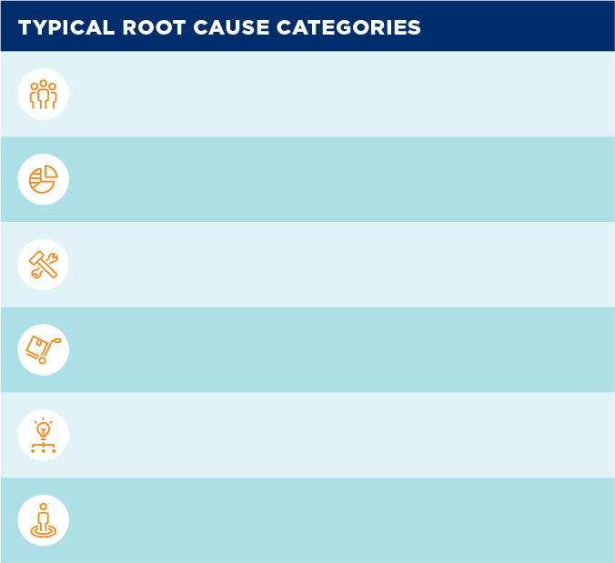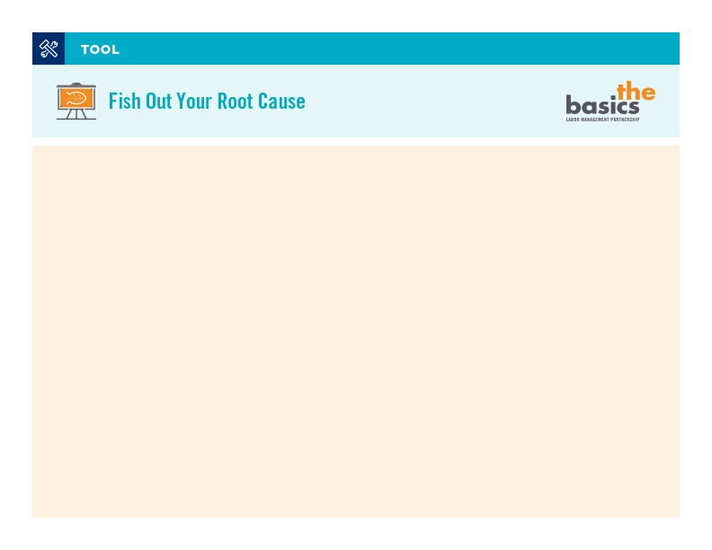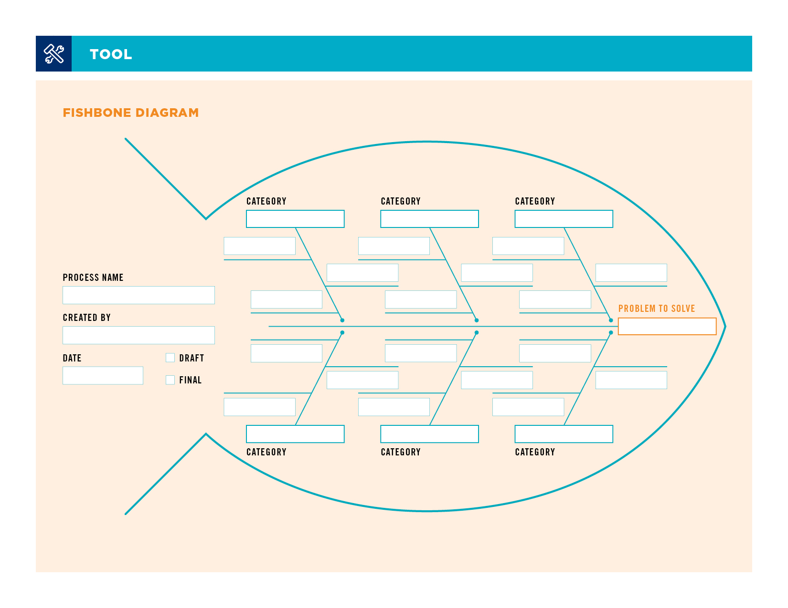

**Purpose:** A fishbone diagram helps identify the root causes of the problems in a process.

**Who:** Level 2 team and higher.

**Directions:** The reverse side of this page includes a simple template for starting a fishbone diagram.

To use the template:

**1.** **Enter the problem** you want to solve in the far right box. Pose it as a question.

**2.** **Enter category names** of likely causes in each of the remaining six boxes. (The suggested categories to the right are just a starting point. Use categories that apply to your work.)

**3.** **Write in brainstormed ideas** about the problem along the diagonal arrow.

**4.** **Add identifying information to the page,** including the process name, who created the process, the date the process was made, and whether the process map is draft or final.

Page **1** / 2

**NOTE:** Fishbone diagrams can be harder than they look. Work with your local improvement advisor or UBT consultant to help lead your team in the process. See completed examples online at **LMPartnership.org/tools/fishbone-examples**.

**people (human factors)**

**Information (data)**

**tools (machines, hand tools fixtures, technology, etc.)**

**materials (supplies, inventory)**

**method (process, assembly steps)**

**milieu (environment)**

Start typing here

Page **2** / 2

X

X

Start typing here

Start typing here

Start typing here

Start typing here

Start typing here

Start typing here

Start typing here

Start typing here

Start typing here

Start typing here

Start typing here

Start typing here

Start typing here

Start typing here

Start typing here

Start typing here

Start typing here

Start typing here

Start typing here

Start typing here

Start typing here

Start typing here

Start typing here

Start typing here

Start typing here

Start typing here

Start typing here

Start typing here

Start typing here