Introduction
As a co-lead, an essential skill in the role of leading the unit- based team to achieve important goals is clear communication with target audiences. You will have several stakeholders that need consistent communication:
- your co-lead(s);
- your team;
- your sponsors; and
- other employees in workgroups outside your UBT.
Clear communication to these stakeholders will help ensure you are able to meet your target goals.

Job Aids, Tools and Templates
- Communication Plan Sample No. 1— Communication Plan for Stakeholders
- Communication Plan Sample No. 2—Communication/ Stakeholder Summary for UBT
- Communication Mapping Tool
- UBT Co-Lead Report to Sponsors Template

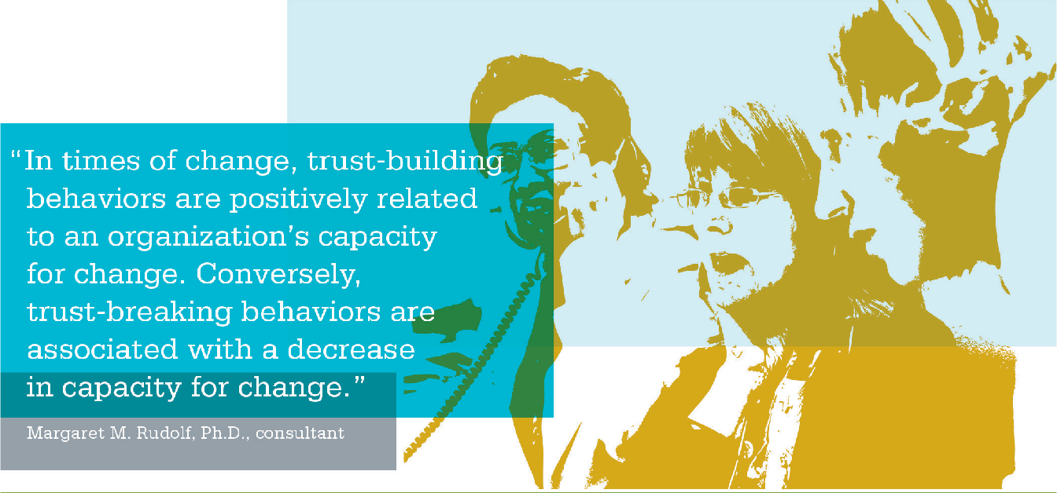

Communication Plan Sample No. 1
Purpose
This tool provides a place to capture the communication information previously reviewed.

Outcomes
After successful completion of this tool, your team will identify the following:
  - what is being communicated;
  - who needs to be communicated to;
  - the method used to communicate and obtain feedback;
  - when and how often the message will be communicated; and
  - who is responsible for communicating this message.

Instructions
Provide a copy of the worksheet to your team. Use
the Communication Mapping Tool and your meeting notes to fill out this tool to ensure communication to all stakeholders.

ACTIVITY: Communication Plan for Stakeholders

SAMPLE NO. 1

Communication Plan: Date:

What are we communicating? | Who do we need to communicate this to? | What method will we use to communicate and how will we obtain feedback? | By when and how often will we communicate this message? | Who is responsible for communicating this message?
(Be specific) | (List internal and external audiences) | (List UBT huddles, newsletters, email or other methods) | (Indicate the frequency and due dates) | (List specific names)

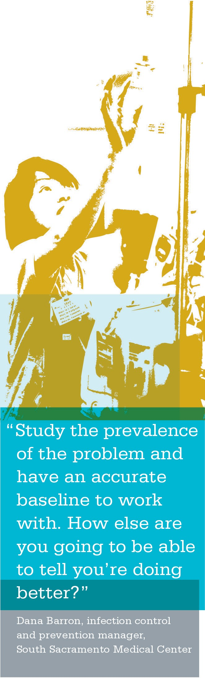
Communication Plan Sample No. 2
Purpose
This tool provides a place to capture the communication information previously reviewed to be given to team members who missed the UBT meeting.

Outcomes
After successful completion of this tool, your team members will identify the following:
- what is being communicated regarding the UBT meeting;
- which team members were absent from the meeting and need information; and
- who is responsible for communicating this message to which team member that missed the meeting.

Instructions
Provide a copy of the worksheet to your team. Use the Communication Mapping Tool and your meeting notes to fill out this tool to ensure communication to all stake- holders who were absent from the meeting and need to be given key details.

ACTIVITY: Communication/Stakeholder Summary for UBT

SAMPLE NO. 2

Date to be completed and given to co-leads:
Date of meeting:

Tell messages | Ask about
Key messages to tell staff about | Key questions to ask staff
1. | 1.
2. | 2.
3. | 3.
4. | 4.
5. | 5.

Name of staff | Who will brief | Initials after brief | Comments | Date
1.
2.
3.
4.
5.
6.
Source: Roxanne WhiteLight, Consultant KPNW

Communication Mapping Tool
Purpose
This worksheet provides an opportunity for team members to identify their communication targets.

Outcomes
After successfully completing this worksheet, UBTs will identify their communication targets.

Instructions
Provide the team with a copy of the Communication Mapping Tool. The team will begin working on the side where the small single box is on top.

Communication Mapping Tool Checklist
[ | ] | Have the UBT review the tool and fill in the boxes starting with the small box on top.
[ | ] | From the top, the team should map out those upon whom they are depending to improve a function (colleagues or others in the work unit who may be interested in their information).
[ | ] | Explain they can cross out any unused boxes on the tool.
[ | ] | How and when will the data be collected, and for how long and how often?
[ | ] | Use this tool throughout the time a UBT is functioning to ensure all stakeholders from workgroups outside the UBT are communicated with effectively.

ACTIVITY: Communication Mapping Tool

Complete the Communication Mapping Tool worksheet and have UBTs identify their communication targets.

UBT Co-Lead Report to Sponsors
Purpose
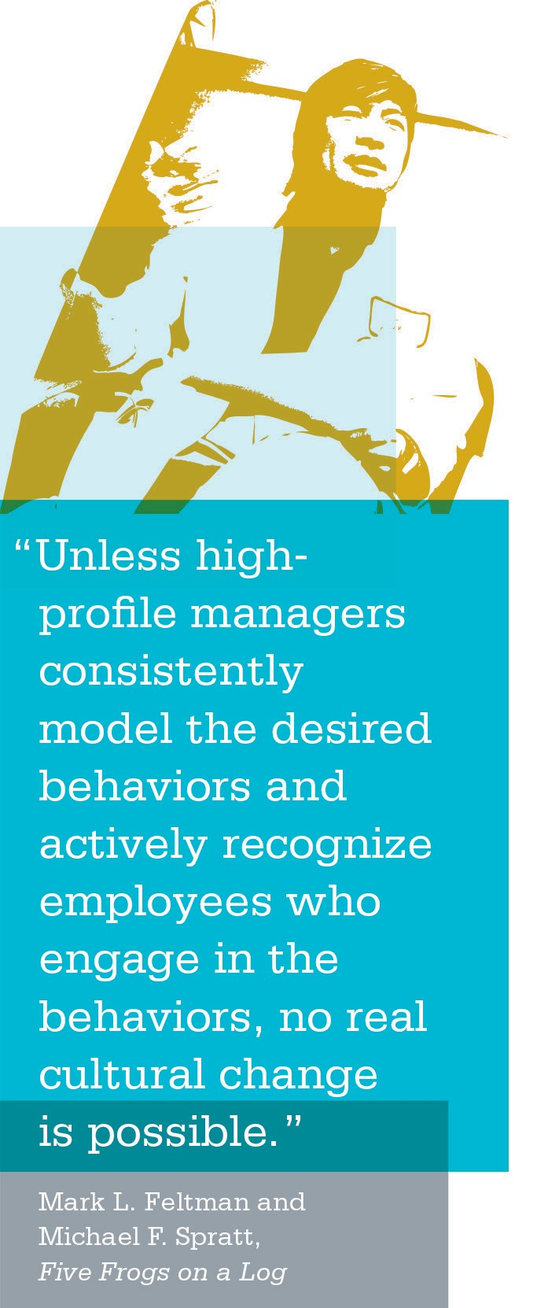
This tool provides the UBT co-leads a way to capture the work focus and progress for the team sponsors.

Outcomes
After successful completion of this tool, your sponsor will know:
- what goal the UBT is working on;
- what measurement they are using to test their success;
- what small tests of change they are doing to further their goal;
- what they have learned from their tests (the results of their tests); and
- whether they have completed the PDSA cycle and implemented any of the small tests of change and, if so, what changes they have implemented.

Instructions
Provide a copy of the worksheet to your UBT sponsors as requested or on a regular basis.

ACTIVITY: UBT Work Reporting

FOR USE BY CO-LEADS TO SPONSORS AND RESOURCE TEAM MEMBERS

Date: | Reporting Period: | Orientation Date:
Team Department and Location:

What goal is the UBT working on?
What measurement are team members using to test their success?
What small tests of change is the team doing to further its goal?
What have team members learned from their tests?/What are the results of the tests?
Have they completed the PDSA cycle and implemented any of the small tests of change? If so, what?
When is the next time overall measurement might reflect the improvements toward this goal? If you already have received this measurement, has it improved over prior performance?
Team engagement on 1–5 scale  with 1 being low and 5 being very good | 1 2 3 4 5
Signature | Phone
Source: Roxanne WhiteLight, Consultant KPNW

Notes

